


Computer Standards & Interfaces 27 (2005) 117 – 132

www.elsevier.com/locate/csi

Extension of Multiprotocol Label Switching for long-range
dependent traffic: QoS routing and performance in IP networks

Tibor Gyiresª, H. Joseph Wen^{b,}*
aSchool of Information Technology, College of Applied Science and Technology, Illinois State University, Normal, IL 61790-5150, USA
b Department of Accounting and Management Information Systems, Donald L. Harrison College of Business,
Southeast Missouri State University, Mail Stop 5815, Cape Girardeau, MO 63701, USA
Received 21 November 2003; accepted 28 May 2004
Available online 26 June 2004

Abstract

This paper presents an extension to the Multiprotocol Label Switching (MPLS) traffic engineering in IP networks with long-
range dependent traffic. The extension provides the ability to diverge traffic flows away from the shortest path calculated by the
traditional IP routing protocols into a less congested area of the network. When the traffic burstiness of a packet flow exceeds a
predefined threshold, the extension calculates the cost of the traffic distribution and the effectiveness of Label Switching
Routers (LSPs) to minimize the number of discarded packets. The simulation results demonstrate that the extension
significantly improves the overall network performance in link utilization, port processor utilization, message delay, number of
dropped packets, and buffer usage level.
D 2004 Elsevier B.V. All rights reserved.

Keywords: Telecommunications; Simulation modeling; Traffic burstiness; MPLS; QoS; RSVP

1. Introduction

The purpose of a communications network is to
support the sharing of the communications links.
When too many packets are present in (a part of)
the subnet, performance degrades. This situation is
called congestion. When the number of packets sent
into the subnet by the hosts is within the network’s
carrying capacity, the packets are all delivered (except
for a few that are damaged or lost due to transmission
errors), and the number delivered is proportional to

* Corresponding author. Tel.: +1-573-651-2121; fax: +1-309-
438-5113.
E-mail address: hjwen@ilstu.edu (H.J. Wen).

0920-5489/$ - see front matter D 2004 Elsevier B.V. All rights reserved.
doi:10.1016/j.csi.2004.05.004

the number sent. However, as traffic increases too far,
the routers are no longer able to forward the packets,
and they begin losing them. This tends to make
matters worse. At very high traffic, performance
collapses completely, and almost no packets are
delivered. Congestion can be caused by several fac-
tors. The most dangerous cause of congestion is the
burstiness of the network traffic. Recent results make
evident that high-speed network traffic is burstier and
its variability cannot be predicted as assumed previ-
ously. It has been shown that network traffic has
similar statistical properties on many time scales.
Traffic that is bursty on many or all time scales can
be described statistically using the notion of long-
range dependency [1,10,20,31]. Long-range depen-

118

T. Gyires, H.J. Wen / Computer Standards & Interfaces 27 (2005) 117–132

dent traffic has observable bursts on all time scales
resulting in packet losses, extremely long response
times and overrun communications link capacities.
The traditional way to control congestion is that the
router detecting the congestion sends a packet to the
traffic source or sources, announcing the problem.
Obviously, these extra packets increase the load when
the subnet is already congested. Feedback-based con-
gestion control systems are not responsive enough to
the varying capacities of transmission links and net-
work delay. The larger the end-to-end delay, the
longer it takes to inform the sending nodes that the
network has become congested. It was shown in Ref.
[5] that the duration of the congestion at the congested
routers is directly related to the bandwidth-delay
product.
In all traditional feedback schemes, the expectation
is that knowledge of congestion will cause the hosts to
take appropriate action to reduce the congestion. But
due to the inherent network delay, the hosts will react
too sluggishly to be of any real use. End-to-end
feedback mechanisms introduce an unacceptable de-
lay. The situation is getting even worse when the
traffic is generated at high-speed in long bursts and
the traffic characteristics cannot be predicted by
traditional statistical methods [16,17].
A good traffic engineering solution that guarantees
the availability of network resources for mission-
critical, interactive and delay-sensitive applications
is Quality of Service (QoS) [2,8]. Its features, such
as queuing, RSVP and multicast services also provide
the control that is needed to handle different traffic in
different ways. Traffic engineering implies the use of
mechanisms to avoid congestion by allocating net-
work resources optimally, rather than continually
increasing network capacities. It is accomplished by
mapping traffic flows to the physical network topol-
ogy along predetermined paths. Traffic engineering
provides the ability to diverge traffic flows away from
the shortest path calculated by the traditional IP
routing protocols into a less congested area of the
network avoiding congestions caused by, e.g., long-
range dependent traffic.
Multiprotocol Label Switching (MPLS) has
emerged as a technology that can provide connection
oriented traffic engineering and QoS. Many future
core networks will use MPLS, including converged
data and voice networks. Traffic engineering is

achieved by forwarding large volumes of voice and
data between Label-Switched Routers (LSRs) together
with bandwidth reservation for traffic flows with
various Quality of Service requirements. MPLS uses
a label switching technique to forward data. A fixed-
format label is inserted in front of each data packet on
entry into the MPLS network. At each hop, the packet
is routed based on the value of the incoming label and
sent out on an outgoing interface with a new label
value. The path that data traverses through a network
is defined by the transition in label values, as the label
is swapped at each LSR. Such a path is called a Label
Switched Path (LSP). In order to distribute the labels
along an LSP, a signaling protocol is required, such as
the Resource Reservation Protocol (RSVP) [4,9].
The objective of our paper is to present an exten-
sion to MPLS in networks with long-range dependent
traffic. We describe a network architecture for mini-
mizing the packet loss due to congestions caused by
long-range dependent traffic. When the traffic bursti-
ness of an LSP increases at an LSR, the router
distributes the traffic flow over n new LSPs leading
to the destination(s) of the original traffic. The selec-
tion of the new LSPs is based on cost estimates of the
flow distribution and routers’ effectiveness in reduc-
ing the number of dropped packets in previous flow
distributions. We define an architecture for the com-
ponents of our MPLS network and the flow distribu-
tion protocol. Using a discrete event simulation
model, we demonstrate how our extension improves
the MPLS technology.
The second section introduces QoS, MPLS and
RSVP. The third section gives an overview of long-
range dependent traffic. The fourth section presents
our Extended MPLS framework and the proposed
flow distribution protocol followed by the conclusion.

2. Overview of QoS, MPLS, and RSVP

2.1. Quality of service (QoS)

A recent survey by infonctics [26] listed QoS as the
second leading concern of IT managers, behind ‘‘se-
curity’’ in its importance in their network design
decisions. QoS is the ability of a network to differen-
tiate between different types of traffic and prioritize
accordingly. It is the cornerstone of any convergence





T. Gyires, H.J. Wen / Computer Standards & Interfaces 27 (2005) 117–132

119

strategy. Voice, video, and data display very different
traffic patterns in the network. Voice and video are
very delay-dependent and have very predictable pat-
terns, whereas data is very bursty and is less delay-
sensitive. If all three types of traffic occur on a
network, the data traffic usually interferes with voice
and video and causes it to be unintelligible. Fig. 1
shows bandwidth requirement and delay-sensitivity of
different types of business applications.
Networked applications are evolving far faster than
the infrastructure that supports them. All this is
creating a problem-poor application performance in
the enterprise. Many enterprises today are faced with
an aged-old dilemma that seems to creep into every
network: Throw more bandwidth at the problem, or
manage the existing bandwidth more effectively. QoS
can effectively improve the usage of existing band-
width [21,22]. It concerns itself with four different
categories of services-bandwidth, latency, jitter, and
loss. The first service category, bandwidth, concerns
itself with how the network manages the entire stream

of data packets flowing through it, particularly in
times of network congestion. The second service
category is latency, the end-to-end delay of a flow.
Numerous applications, including voice and video,
have a specific end-to-end delay budget. If a packet is
delayed beyond the allocated budget, the data
becomes stale or is no longer relevant. The third
category addresses the need to control jitter, the
variations in latency between packets. The final
category concerns the need to manage packet loss.
As a consequence of congestion, packet loss has two
purposes. First, reducing the number of packets
competing for output link can relieve the level of
congestion. Second, when sending hosts notice that
some packets are being discarded, they usually reduce
the volume of traffic they are injecting into the
network. While this is an effective approach for
managing congestion, many applications can only
tolerate a small amount of packet loss. The proposed
MPLS extension is mainly to minimize packet loss
and to control jitter.

Fig. 1. QoS requirements of various computer applications.

120

T. Gyires, H.J. Wen / Computer Standards & Interfaces 27 (2005) 117–132

2.2. Multiprotocol Label Switching (MPLS)

MPLS has emerged as an enabling technology for
new public networks due to its support for traffic
engineering. It is capable to forward large volumes of
voice and data between Label-Switched Routers
(LSRs). Because MPLS can simultaneously support
multi-layer services (Layers 2 and 3), it has gained
support from many standards organizations, equip-
ment providers and service providers. Telecommuni-
cations carriers can integrate multiple single-service
networks onto an integrated MPLS core. There is
already a large MPLS market because the technology
provides the foundation of many IP Virtual Private
Network (VPN) services. The next generation of
MPLS development will improve traffic engineering,
offer new services and integrate existing service plat-
forms. Each development will require a new infra-
structure because existing equipment will not be
powerful enough to support the new services. Vendors
have started to develop extensions to MPLS that are
focused on particular applications. Our proposed
extension to MPLS is unique in its traffic engineering
category. The addition of the new features largely
depends on the resource and QoS requirements of the
implementation in the routers and switches in an
MPLS network.
MPLS does not replace IP routing, but will work
together with existing routing technologies to provide
very high-speed data forwarding between LSRs. A
fixed-format label is inserted in front of each data
packet on entry into the MPLS network. At each hop
across the network, the packet is routed based on the
value of the incoming label and sent out on an

outgoing interface with a new label value. The path
that data traverses through a network is defined by the
transition in label values, as the label is swapped at
each LSR. Since the mapping between labels is
constant at each LSR, the path is determined by the
initial label value. Such a path is called a Label
Switched Path (LSP). The basic operation of an
MPLS network is depicted in Fig. 2 similar to the
one in Ref. [6].
At the entry to the network, called ingress, each
packet is examined to determine which LSP it should
use based on the destination address, the quality of
service requirements, and the current state of the
network. The group of similar packets forwarded in
the same way is known as a Forwarding Equivalence
Class (FEC). One or more FEC may be mapped to a
single LSP. The diagram above shows two data flows
from host A: one to host B and one to host C. Two
LSPs are depicted. LSR1 is the ingress point to the
network to transmit data from and to host A. When
LSR1 receives packets from A, it determines the FEC
for each packet, determines the LSP to use, and inserts
a label to the packet. LSR1 then forwards the packet
on the appropriate outgoing interface defined for the
LSP. LSR2 examines the labeled packet received on
the incoming interface and refers to a lookup table to
decide the outgoing interface to send out the packet.
As shown in Fig. 2, each packet with label 15 will be
sent out on the interface to LSR3 with label 36. Label
23 will be swapped with label 19 and the packets will
be sent to LSR4. LSR3 and LSR4 are exit routers,
called egress LSRs from the MPLS network. The
egress LSRs remove the labels from the packets and
forward them using traditional IP routing.

Fig. 2. LSPs and LSRs in an MPLS network.

T. Gyires, H.J. Wen / Computer Standards & Interfaces 27 (2005) 117–132

121

LSPs are setup using the lookup tables at each LSR
that map the pairs (incoming interface, label) to the
pairs (outgoing interface, label) in the table entries.
The process that updates and creates the table entries
is called label distribution. The label distribution
protocol that establishes LSPs between LSRs can play
an important role in implementing Traffic Engineering
functions. The class of service and quality of service
required for traffic flows can also be included in the
Traffic Engineering process. There are currently two
label distribution protocols that provide support for
Traffic Engineering: RSVP and Constrain-based rout-
ed Label Distribution Protocol (CR-LDP). The main
differences between the two protocols are the reliabil-
ity of the transport protocol and direction of the
resource reservation, i.e., the reservation is done in
the forward or reverse direction. Each protocol has its
supporters and opponents, and the protocols are still
being developed by the Internet Engineering Task
Force (IETF). We chose RSVP to demonstrate our
Traffic Engineering protocol for reasons discussed
below.

2.3. Overview of RSVP

Originally, RSVP was developed as the signaling
protocol of the Integrated Services (IntServ) frame-
work to provide QoS support in IP based networks
[27,29]. The framework defines a flow as a stream of
related datagrams between hosts that is created by a
single application or user activity and requires the
same QoS. The physical path of the flow across a
network is determined by conventional destination-
based routing. A flow is a simplex mode of packet
transmission. Quality of Service is implemented in a
router and a host for a particular data flow by a
module called traffic control. It includes the Packet
Classifier, Admission Control, Policy Control, Packet
Scheduler, and the Estimator [27,29].
RSVP reserves resources in routers along the
traffic flow as requested by an application. RSVP
can be considered the configuration protocol for
IntServ. The sending host sends a PATH message
to the destination(s) of the traffic flow. It carries the
flow specification of the offered load: the identity of
the application, the traffic characterization (band-
width, burstiness, average and peak transmission
rate), and data for traffic classification. When the

PATH message arrives at the destination(s), it
responds by sending RESV messages identifying
the requested flow specification: the receiving appli-
cation, the type of services (latency bound, mini-
mum bandwidth guarantee, etc.) and the amount of
resources requested by the destination(s). RESV
messages return to the source along the reverse path
of the PATH messages. As RESV messages arrive at
the routers, the devices decide whether there are
sufficient resources available for the traffic flow. If
there are enough resources and there is no conflict
between the request and local policies established
for the destination, the request is admitted. Other-
wise, the request is rejected and an error message is
sent to the network devices along the path notifying
other RSVP-aware devices that the request was not
admitted.
RSVP has become a proposed standard and is
currently widely implemented in IP networking equip-
ment. However, RSVP has not been widely used in
service provider networks because of the lack of its
scalability and the overhead required supporting large
number of host-to-host flows. A number of extensions
were added to the original RSVP specification to
reduce the effect of the deficiencies above. The
designers of MPLS chose to further extend RSVP
into a signaling protocol to create LSPs that could be
automatically routed away from network congestions.
The main reasons that the designers of MPLS chose to
extend RSVP rather than design a new signaling
protocol to support traffic engineering requirements
are the following [30]:

(1) RSVP was designed for resource reservation
across a set of multicast or unicast Internet traffic
paths. Reservation is an important component of
traffic engineering that has made RSVP a good
candidate to implement it.
(2) RSVP allows carrying opaque objects in its
messages processed by the various modules in a
router. This feature makes it easier to add new
RSVP objects that can be used to create and
maintain distributed state information other than
resource reservation. The traffic engineering
extensions can easily be developed to extend
RSVP to support explicit routing and label
distribution that are essential traffic engineering
requirements.

122

T. Gyires, H.J. Wen / Computer Standards & Interfaces 27 (2005) 117–132

(3) The extended RSVP is backward compatible with
traditional RSVP implementations. It can differ-
entiate between LSP signaling and traditional
RSVP reservations by examining the objects
contained in the signaling messages.

3. Long-range dependent traffic

For more details of long-range dependency in
time series and the associated statistical tests, see
Refs. [19,23,31]. We follow the definitions of these
papers.

3.1. Definitions

Let X=(X_{t}: t = 0, 1, 2, . . .) be a covariance stationary
stochastic process. Such a process has a constant mean
l = E[X_{t}], finite variance r²= E[(X_{t}l)²], and an
autocorrelation function r(k) = E[(X_{t}l)(X_{t}+ k^{l})]/
E[(X_{t}l)²] (k = 0, 1, 2, . . .) that depends only on k. It
is assumed that X has an autocorrelation function of the
form:

H ! 1, the extent of both self-similarity and long-
range dependence increases. It can also be shown that
for self-similar processes with long-range dependency
H>0.5 [31].
There are various network models for characteriz-
ing the bursty nature of network traffic. Most of the
models focus on the Hurst parameter only and do not
consider the time scale from which the degree of long-
range dependency, the burstiness of the traffic, begins
to appear. As it has been demonstrated in Ref. [28],
the Hurst parameter alone is not sufficient to com-
pletely characterize traffic burstiness. The Hurst pa-
rameter only shows how fast or slowly the burstiness
increases or decreases but does not capture the range
of time scales over which the long-range dependency
nature of the network traffic becomes visible. The
paper describes that the time scales can be captured by
a parameter called Fractal Onset Time Scale (FOTS).
It shows the beginning of the time scale from which
the bursty nature of the traffic becomes evident. As
the FOTS becomes a smaller and smaller scale, the
traffic burstiness increases. Therefore, the traffic
burstiness can be characterized not just by the Hurst
parameter alone but by three parameters, namely the

rрkЮfak^{b}; k ј 1; 2; 3; . . .
р1Ю
average arrival rate of the network traffic, the Hurst
parameter, and the FOTS. After the authors of the

where 0 < b < 1 and a is a positive constant. Let
paper [28], we call them the Three Fundamental

X⁽m)₌₍X₍k)
(m):k = 1, 2, 3, . . ., m = 1, 2, 3, . . .) repre-
Parameters (TFPs). The paper illustrates the use of

sent a new time series obtained by averaging the
original series X over non-overlapping blocks of
size m. For each m = 1, 2, 3,. . ., X⁽m) is specified by
X_{k}(m) = 1/m(X_{km}m + 1⁺. . . + X_{km}), (k z 1). Let r⁽m)
denote the autocorrelation function of the aggregat-
ed time series X⁽m).
The process X is called exactly self-similar with self-
similarity parameter H = 1 b/2 if the corresponding
aggregated processes X⁽m) have the same correlation
structure as X, i.e., r⁽m)₍k) = r(k), for all m = l, 2, . . .
(k = l, 2, 3, . . .).
A covariance stationary process X is called asymp-
totically self-similar with self-similarity parameter
H = 1 b/2 if for all k large enough r⁽m)₍k) ! r(k),
m = 1, 2, 3, . . ., 0.5 V H V 1.
A stationary process is called long-range depen-
dent if the sum of the utocorrelation values ap-
proaches infinity: A_{k}r(k) ! l.
The Hurst parameter H represents the speed of
decay of a process’ autocorrelation function. As
the TFPs in various Fractal Point Process models that
have been implemented in the OPNET network mod-
eling tool in the form of Raw Packet Generators. For
technical reasons, we chose the M/Pareto model to
characterize traffic burstiness. We implemented the
model and the TFPs in the COMNET modeling tool
based on captured bursty traffic traces. See the details
in Appendix A.

4. MPLS extension

Our framework is similar to the one in Ref. [15]
applied for MPLS network. It extends MPLS by
adding new functionalities to the framework. The
new functionalities further augment the functions of
the LSR’s Estimator. We assume that the Traffic
Control database of an LSR has the following knowl-
edge of flows terminating at or crossing the router:
flow identifier, required resources, priority, and the

T. Gyires, H.J. Wen / Computer Standards & Interfaces 27 (2005) 117–132

123

maximum number of flows that can be established on
outgoing links.
Reassignment cost: Assuming a packet flow T_{i}. In
the subsequent paragraphs, we will explain that T_{i}is
going to be distributed over some number of new
LSPs if the traffic burstiness exceeds a threshold
value. Let us denote the distributed portion of the
packet flow T_{i}on path j by T_{ij}. Each router that is in a
distribution path may have to make some resource and
routing reassignments. Aij(R) denotes the cost of such
a reassignment at LSR R for a distributed flow T_{ij}. It
includes the costs for assigning buffers to the flow
being distributed, rerouting lower priority flows, etc.
The LSR’s Estimator estimates this cost based on
predefined entries in a cost table created by the
network service provider.
Discarded packets: Each Estimator can estimate
the packet loss in the new, distributed flow. P_{ij}(R)
denotes the estimated number of packets discarded at
LSR R in the distributed flow T_{ij}.
E-parameter: The E-parameter for LSR R,
denoted by E_{ij}(R) is a measure of its efficiency in
rerouting a distributed portion T_{ij}of the packet flow
T_{i}on path j. Small (close to zero) values of the E-
parameter indicate high quality and efficiency, and
high values indicate that router R is unreliable and
unstable in rerouting of distributed traffic. The Esti-
mator recalculates a router’s E-parameter after each
flow distribution using the E values from previous
flow distributions. After each flow distribution, it is
determined how realistic an LSR’s cost estimate has
been with respect to the actual cost. By testing a
statistical hypothesis, it can be determined if it has
been unrealistic. If the corresponding hypothesis H₀
is rejected, no request messages will be sent to this
router in the future for diverting distributed flow. If a
router’s cost estimate has been realistic, i.e., the
corresponding hypothesis H₀is accepted, the E-
parameter is recalculated. The closer the estimated
cost is to the actual cost, the smaller is the E-
parameter. A local network administrator provides
initial values of E. Subsequent values of the E-
parameter are calculated using the statistical sam-
pling method given in Ref. [12]. The motivation for
using the E-parameter is to enable the traffic distri-
bution process to learn from past performances and
use this knowledge to select the most efficient
distribution paths.

Distribution cost: The cost associated with a dis-
tributed flow T_{ij}of flow T_{i}is the sum of reassignment
costs, the estimated discarded packets, and the E-
parameters along a path j. The cost of a distributed
flow T_{ij}(R,P) between two remote LSRs R and P is
denoted by C(T_{ij}(R,P)) and defined recursively by:
CрT_{ij}рR; PЮЮ ј ЅCрT_{ij}рQ; PЮ ю E_{i}рQЮ ю A_{ij}рQЮ
ю P_{ij}рQЮ;
where R and Q denote adjacent LSRs along the path j.

4.1. Flow distribution protocol

IntServ recommends the use of the Token Bucket
scheme to characterize the degree of burstiness. A
Token Bucket is defined by two parameters: a token
rate T that specifies the sustainable data rate of the
traffic flow, and the bucket size B that specifies the
amount by which the data rate can exceed T for short
periods of time. However, measurements of real traffic
indicate that burstiness is present on a wide range of
time scales that can be described statistically using the
notion of long-range dependency. Long-range depen-
dent traffic has observable bursts on all time scales.
As we discussed it in the previous section, an appro-
priate way of measuring traffic burstiness is based on
the estimate of the TFPs of the network traffic.
Therefore, characterizing burstiness based on the
TFPs is more appropriate than the Token Bucket
scheme that is based on measurements of only short
periods of time. We are going to apply the statistical
method developed in Ref. [11] to estimate the FOTS
of bursty traffic flows.
In our flow distribution protocol, the specification
of a new packet flow and subsequent control packets
carry the anticipated traffic’s TFPs. It is calculated
from previous connections and applications’ traffic
patterns at the sending host. It can also be estimated
and updated by intermediate LSRs. Different LSRs
can accommodate the same bursty traffic differently.
For instance, an LSR can reserve more input buffers
for the incoming packet flow; another router can
assign more processing power for handling the flow,
etc. We also assume that the specification of a new
packet flow contains the average traffic volume V in
bits per second that the router can handle based on
empirical observations. (Note that this measurement

124

T. Gyires, H.J. Wen / Computer Standards & Interfaces 27 (2005) 117–132

is not necessarily the forwarding capability of the
router).
When the TFPs of the flow specification of a new
request or the traffic burstiness of an existing flow
exceed certain thresholds, the router divides the traffic
into n new LSPs. Instead of using a single path, the
LSR will divide the traffic flow over n number of new
paths, leading to the destination(s) of the original
traffic. (For simplicity, we assume unicast instead of
multicast sessions. The protocol below can easily be
expanded for multicast as well.) The n new LSPs will
reunite at the destination using some existing techni-
ques, such as packet sequence numbering. The flow
distribution is implemented in the following steps.
Step 1. Assume that LSR X detected that the traffic
burstiness of a flow or the TFPs of a new request
exceed certain thresholds. X estimates the volume
requirement of the flow based and sends a PATH
message and the flow specification to the destination
LSR Y requesting resources for the flow. The PATH
message also request LSR Y to provide a label for the
new LSPs.
Step 2. LSR Y sends an RESV packet back to X on
all paths towards X. The RESV packet can follow
existing LSPs or any paths determined by standard IP
routing. The RESV packet contains the label that the
downstream LSR communicates to its upstream
neighbor. The RESV packets are reproduced at each
subsequent LSR along the paths to X. The RESV
packet is sent upstream towards LSR X. Each LSR
that receives a RESV packet with a label will use the
received label for outgoing traffic along the new LSP.
Step 3. Each RESV stores all visited LSRs along
the path in the packet’s data field.
Step 4. Each RESV carries the flow specification
requesting resources for flow distribution at each
LSR. An LSR’s Estimator estimates the resource
requirement of the flow. If there are enough resources,
the request is tentatively admitted and reservation is
made for a portion or for all of the requested resour-
ces. If the request is rejected, reject messages are sent
along the path, notifying MPLS-aware routers of the
failure. (Note that the reservation does not guarantee
that packets will not be lost because it is based on an
estimate only.) The reservation is valid only for a
limited t time interval. If there is no confirmation
arriving for the reservation in time t, the resources can
be reallocated for other purposes.

Step 5. Each RESV collects estimates of the
reassignment costs, discarded packets, the E-parame-
ter, and the reserved traffic volume from the Estimator
at each visited LSR.
Step 6. Upon receiving all cost estimates from all
paths, LSR X selects the n LSPs with the least
distribution costs that collectively can carry the vol-
ume of the original flow, and distributes the new or
existing traffic along the new T_{ij}flows, j = 1,2,. . .n.
(See the calculation below).
Step 7. After flow distribution, each Estimator
compares the actual cost and the estimated cost and
recalculates its own E-parameter for subsequent flow
distribution [12]. It can be proven similarly to Ref.
[12] that the newly selected LSPs are optimal in terms
of the distribution cost and overall packet losses.
When the traffic burstiness falls below a certain
threshold value, the distributed traffic flows are col-
lapsed into the original single flow. If the flow’s
resource requirement exceeds the LSR’s resources
before the selection of the ‘‘least-cost’’ LSPs is
completed, then X makes the decision immediately
based on data from previous flow distributions.

5. Simulation method

A network system is a set of network elements
[18], such as routers, switches, links, users, and
applications working together to achieve some tasks.
The state of a network system is the set of relevant
variables and parameters that describe the system at a
certain time that comprise the scope of this study.
Instead of building a physical model of a network, we
build a mathematical model representing the behavior
and the logical and quantitative relations between
network elements. By changing the relations between
network elements, we can analyze the model without
constructing the network physically, assuming that the
model behaves similarly to the real system, i.e., it is a
valid model. For instance, we can calculate the
utilization of a link analytically, using the formula
U = D/T, where D is the amount of data sent at a
certain time and T is the capacity of the link in bits per
second. This is a very simple model that is very rare in
real world problems. Unfortunately, the majority of
real world problems are too complex to answer ques-
tions using simple mathematical equations. However,

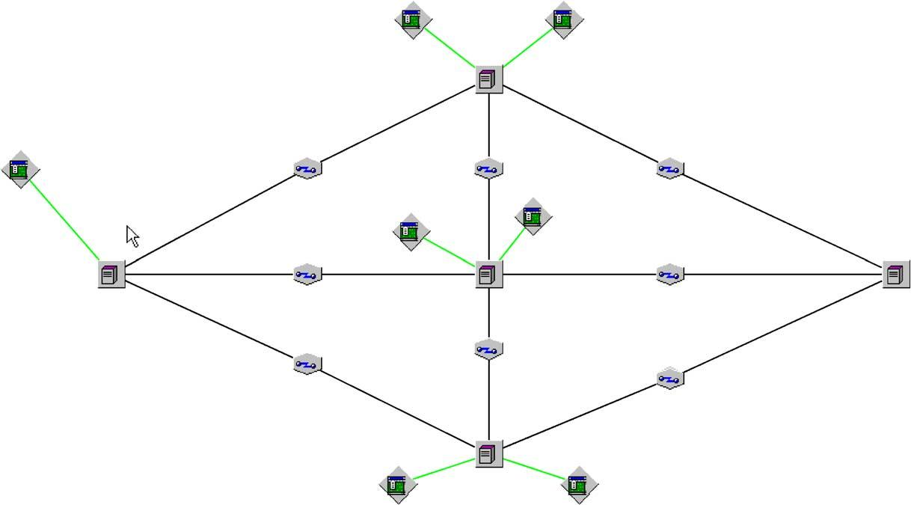

T. Gyires, H.J. Wen / Computer Standards & Interfaces 27 (2005) 117–132

125

in highly complex cases, simulation technique is more
appropriate. Simulation models can be classified in
many ways. The most common classifications are as
follows:

5 Static and dynamic simulation models: A static
model characterizes a system independently of
time. A dynamic model represents a system that
changes over time.
5 Stochastic and deterministic models: If a model
represents a system that includes random elements,
it is called a stochastic model. Otherwise it is
deterministic. Queuing systems, the underlying
systems in network models, contain random
components, such as arrival time of packets in a
queue, service time of packet queues, output of a
switch port, etc.
5 Discrete and continuous models: A continuous
model represents a system with state variables
changing continuously over time. Examples are
differential equations that define the relationships
for the extent of change of some state variables
according to the change of time. A discrete model
characterizes a system where the state variables

change instantaneously at discrete points in time.
At these discrete points in time some event or
events may occur, changing the state of the
system. For instance, the arrival of a packet at a
router at a certain time is an event that changes the
state of the port buffer in the router.

In our study, we assume dynamic, stochastic, and
discrete network models. We refer to these models as
discrete-event simulation models.
Due to the complex nature of computer communi-
cations, network models tend to be complex as well.
The development of special computer programs for a
certain simulation problem is a possibility, but it may
be very time consuming and inefficient. Recently, the
application of simulation and modeling packages has
become more customary, saving coding time and
allowing the modeler to concentrate on the modeling
problem in hand instead of the programming details.
In a world of more and more data, computers,
storage systems, and networks, the design and man-
agement of systems are becoming an increasingly
challenging task. As networks become faster, larger,
and more complex, traditional static calculations are

Fig. 3. The COMNET model of an IP network.

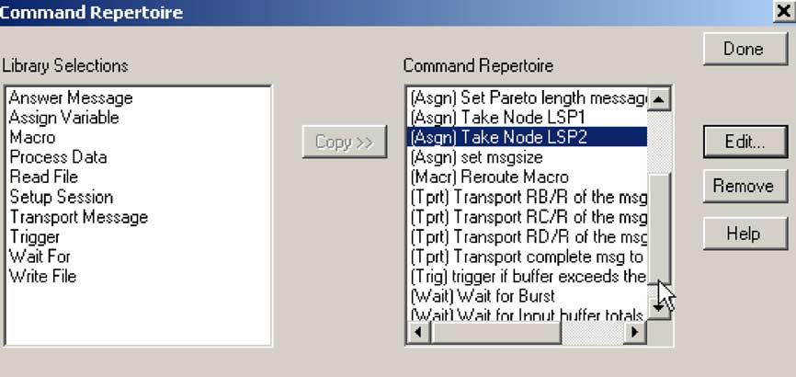
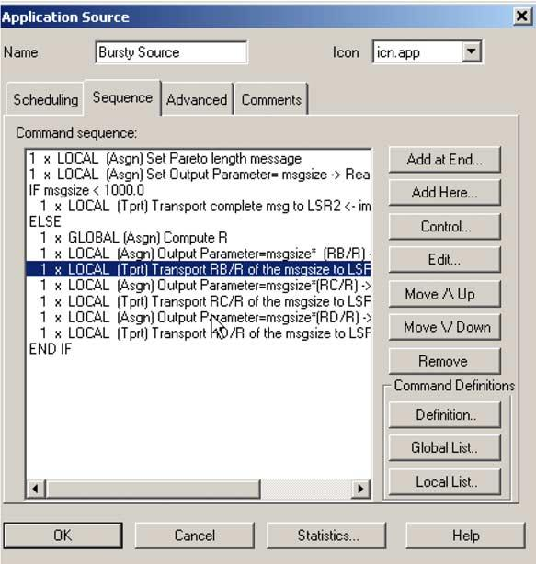

126

T. Gyires, H.J. Wen / Computer Standards & Interfaces 27 (2005) 117–132

no longer reasonable approaches for validating the
implementation of a new network design and multi-
million dollar investments in new network technolo-
gies. Complex static calculations and spreadsheets,
bottleneck analysis and/or queuing analysis are not
appropriate tools any more due to the stochastic nature
of network traffic and the complexity of the overall
system.
Organizations depend more and more on new
network technologies and network applications to
support their critical business needs. As a result, poor
network performance may have serious impacts on the
successful operation of their businesses. In order to
evaluate the various alternative solutions for a certain
design goal, network designers increasingly rely on
methods that help them evaluate several design pro-
posals before the final decision is made and the actual
systems is built. A widely accepted method is perfor-
mance prediction through simulation. A simulation
model can be used by a network designer to analyze
design alternatives and study the behavior of a new
system or the modifications to an existing system
without physically building it. A simulation model
can also represent the network topology and tasks
performed in a network in order to obtain statistical
results about the network’s performance.
Simulation of large networks with many network
elements can result in a large model that is difficult to
analyze due to the large amount of statistics generated
during simulation. Therefore, it is recommended to
model only those parts of the network which are
significant regarding the statistics we are going to

Fig. 5. Application bursty source in the simulation.

obtain from the simulation. It is crucial to incorporate
only those details that are significant for the objectives
of the simulation.
Depending on the objectives, the same network
might need different simulation models. For instance,
if the modeler wants to determine the overhead of a
new service of a protocol on the communication links,
the model’s links need to represent only the traffic
generated by the new service. In another case, when
the modeler wants to analyze the response time of an

Fig. 4. The command repertoire in the simulation.

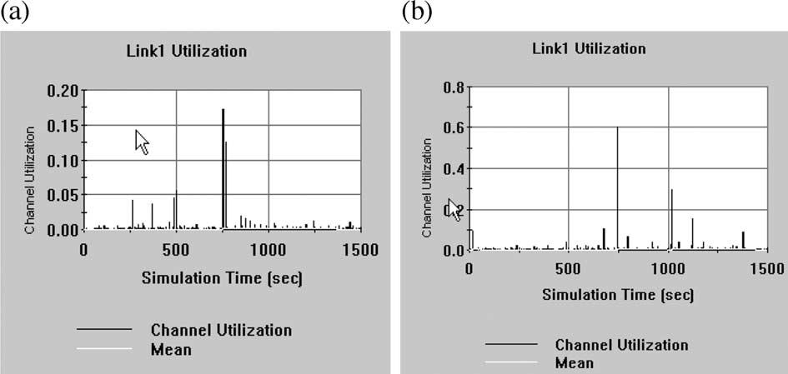

T. Gyires, H.J. Wen / Computer Standards & Interfaces 27 (2005) 117–132

127

Table 1
Number of packets dropped and input buffer usage

results when looking at an entire network. Modeling
the details of the routers’ internal operations in the

Node # of packets blocked
Max. buffer use in bytes
order of magnitude of nanoseconds does not contrib-

Without traffic
With traffic Without traffic
With traffic
ute significantly to the end-to-end delay analysis in

distribution
LSP2 127
LSP3 0
LSP4 0
LSP5 0
distribution
0
0
0
0
distribution
4,992,000
0
0
0
distribution
2,202,849
2,202,849
2,202,849
4,405,698
the higher order of magnitude of microseconds or
seconds. The additional accuracy gained from higher
model granularity is far outweighed by the model’s
complexity and the time and effort required by the
inclusion of the routers’ details.
Simplification can also be made by applying sta-

application under maximum offered traffic load, the
model can ignore the traffic corresponding to the new
service of the protocol analyzed in the previous model.
Another important question is the granularity of the
model, i.e., the level of details at which a network
element is modeled. For instance, we need to decide
whether we want to model the internal architecture of
a router or we want to model an entire packet switched
network. In the former case, we need to specify the
internal components of a router, the number and speed
of processors, types of buses, number of ports, amount
of port buffers, and the interactions between the
router’s components. However, if the objective is to
analyze the application level end-to-end response time
in the entire packet switched network, we would
specify the types of applications and protocols, the
topology of the network and link capacities, rather
then the internal details of the routers. Although the
low level operations of the routers affect the overall
end-to-end response time, modeling the detailed oper-
ations do not significantly contribute to the simulation
tistical functions. For instance, modeling cell errors in
an ATM network does not have to be explicitly
modeled by a communication link by changing a bit
in the cell’s header, generating a wrong CRC at the
receiver. Rather, a statistical function can be used to
decide when a cell has been damaged or lost. The
details of a cell do not have to be specified in order to
model cell errors. These discussions demonstrate that
our goal of network simulation in this study is to
reproduce the functionality of a network pertinent to a
certain analysis, not to emulate it.

6. Simulation results

For the sake of simplicity and for the illustration of
our model, we implemented a slightly modified ver-
sion of the distribution cost calculation in the simula-
tion. Let V denote the average traffic volume in bits
per second that is going to be distributed. Let
C₁V C₂V ,. . . V C_{k}denote the cost estimates along k

Fig. 6. Utilization of link AB (a) without and (b) with traffic distribution.

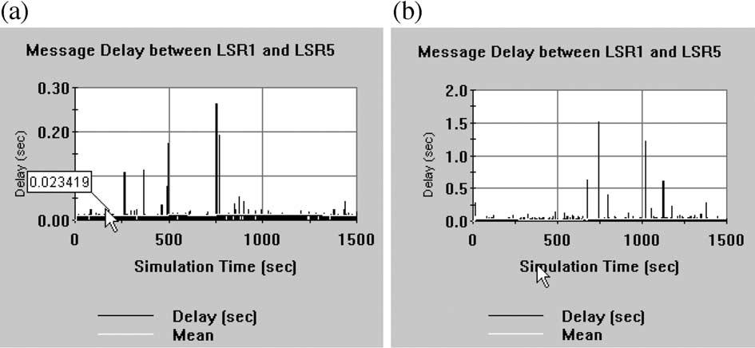

128

Table 2

T. Gyires, H.J. Wen / Computer Standards & Interfaces 27 (2005) 117–132

Table 3

Average and maximum utilization of Link1
Average and maximum message delay between LSR1 and LSR5

Link1
Average
utilization (%)
Maximum
utilization (%)
Message delay between
LSR1 and LSR5
Average
delay (msec)
Maximum
delay (msec)

Without traffic distribution 0.2600
60.0
Without traffic distribution
46.83
1517

With traffic distribution
0.0848
17.8
With traffic distribution
10.815
261.8

LSPs. LSR X will choose the first n LSPs, n V k, for
which V = V/C1 + V/C2 + . . . + V/Cn, and 1/C1 + . . . +
1/Cn = 1.
In our simulation, we want to make sure that the
traffic be distributed among the LSRs routers pro-
portionally to the available buffer sizes. Let the cost
estimate C_{i}= 1/R_{i}, where R_{i}is the available buffer
size in bytes at LSR_{i}. Let us arrange the available
buffer sizes R₁z R₂z ,. . . z R_{k}and compute the
sum R₁+ R₂+ . . . + R_{k}= R. The simulation model
distributes the flow proportionally to the available
buffer size:

V ј VR₁=R ю VR₂=R ю . . . ю VR_{n}=R; where

R₁=R ю . . . ю R_{n}=R ј 1:

The motivation of LSR X’s decision is that the
higher an LSR’s cost estimate the lesser amount of
traffic will be distributed via that LSR.
We implemented the flow distribution protocol in
the discrete event simulation system COMNET [7]
based on real traffic traces captured in a large private
network with bursty traffic. With slight modifications,
similar models have been used in various papers and

contexts to illustrate the affect of burstiness on differ-
ent network protocols, such as DiffServ and IntServ,
etc. [13 – 15,24,32]. In this paper, we assume that the
selection algorithm above has already identified the
paths with the least cost estimates. In order to dem-
onstrate our distribution algorithm, we constructed the
following simplified model in COMNET.
In Fig. 3, LSR1 through LSR5 denote the routers
of the MPLS network connected by OC-3 links:
Link1, Link2, etc. LSR1 is the origin; LSR5 is the
destination of one or more Label Switched Path
(LSP). There are three objects, so-called application
sources, attached to the LSRs: ‘‘Bursty Source,’’
‘‘Compute Available Buffer,’’ and ‘‘Forward’’. Appli-
cation sources implement the behavior of an applica-
tion by creating simple scripting language commands
in the node where the application sources are attached
to. For instance, the node LSR1 implements the
commands in Fig. 4. Commands are taken from a
Library of commands specific to a node and custom-
ized according to the application source using these
commands.
The application source ‘‘Bursty Source’’ attached
to LSP1 represents an MPLS path and implements the
Path Distribution Protocol. Bursty Source sends mes-

Fig. 7. Message delay (a) without and (b) with traffic distribution.

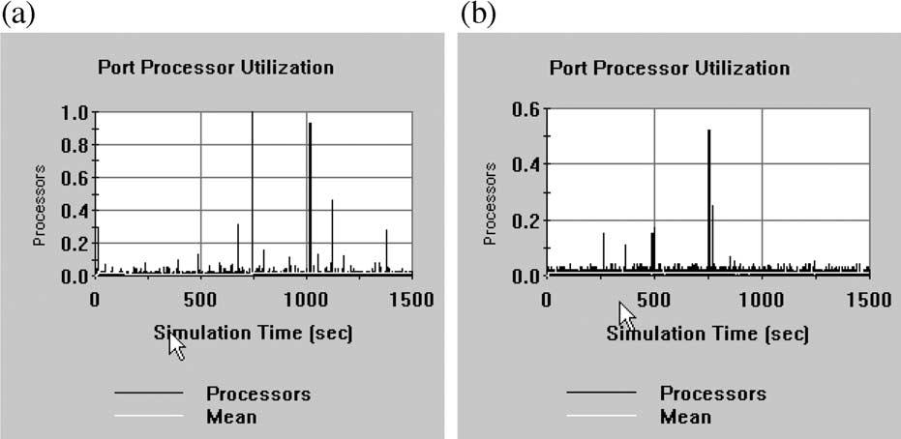
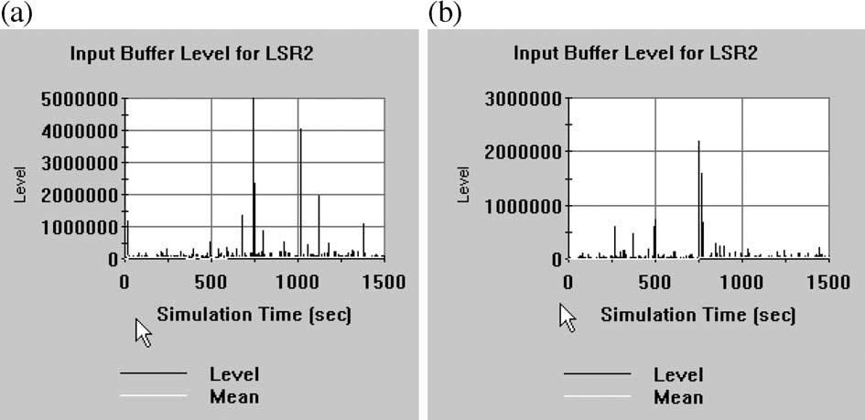

T. Gyires, H.J. Wen / Computer Standards & Interfaces 27 (2005) 117–132

Fig. 8. Port processor utilization (a) without and (b) with traffic distribution.

129

sages to the destination with varying TFPs. If the
traffic burstiness is less than a threshold, LSR1 will
choose a path via LSR2. Otherwise, it will distribute
the traffic among the adjacent routers identified by the
selection algorithm shown in Fig. 5.
The ‘‘Compute Available Buffer’’ takes samples of
the current size of buffer capacities of the LSPs in
every second and transmits it to LSP1. The sizes of
the available buffers are needed for the path distribu-
tion protocol. We can assume that routers can deter-
mine the buffers available for a certain traffic flow.
The ‘‘Forward’’ application source implements the
forwarding function of the LSPs.
We ran the simulation for 8000 s with and without
traffic distribution and measured the number of pack-

ets dropped at the routers. The simulation statistics
show (in Table 1) that 127 packets have been dropped
without traffic distribution and no packets have been
dropped with traffic distribution due to the lack of
buffer space.
For Link1, as shown in Fig. 6 and Table 2, the
average utilization was 0.26% and 0.09% without and
with the traffic distribution respectively. The maxi-
mum utilization for Link1 could reach 60% when the
traffic distribution method was not implemented.
Fig. 7 is the results for the corresponding message
delay between LSP1 and LSP5. The message delay
gets longer if no traffic distribution is implemented.
Longer message delay (response time) can critically
affect users’ productivity. Table 3 demonstrates that

Fig. 9. Input buffer level for LSR2 (a) without and (b) with traffic distribution.

130

T. Gyires, H.J. Wen / Computer Standards & Interfaces 27 (2005) 117–132

the average message delay between the source and
destination LSPs is significantly less with traffic
distribution.
The traffic distribution method also results in
significant reduction of the port processor’s utilization
as it is shown in Fig. 8. The port utilization is very
close to 100% without flow distribution. Very high
processor utilization may drastically decrease the
performance of the LSRs.
As a consequence of high port processor utiliza-
tion, the buffer usage levels of the LSPs are also
higher without traffic distribution. The result of high
buffer usage level is in longer waiting times in packet
queues and increasing number of dropped packets.
Fig. 9 shows the buffer level of LSR2 with and
without flow distribution. Due to space limitations,
we do not include all the details, such as the message
interarrival time, traffic burstiness threshold, buffer
sizes, the full command sequence, etc. The details are
available from the authors upon request.
In summary, the simulation results demonstrate
that the flow distribution improves the overall net-
work performance in link utilization, port processor
utilization, message delay, number of dropped pack-
ets, and buffer usage level.

7. Conclusion

The paper presented an extension of MPLS traffic
engineering to reduce the number of discarded packets
during congestions caused by bursty, long-range de-
pendent traffic. When the traffic burstiness of a packet
flow exceeds a certain threshold at an LSR, the router
selects n new LSPs to distribute the original long-
range dependent traffic over these LSPs. The selection
is based on cost estimates of the traffic distribution
and the effectiveness of the LSPs in reducing the
number of discarded packets in previous traffic dis-

network resources. In our proposed extension version,
an LSP can still be established for long-range depen-
dent traffic that would not be possible in the current
version of MPLS. The main limitation of this study,
however, is the inadequate capabilities of the current
network routers. The routers have to implement the
functions needed to make decisions on various net-
work parameters, such as burstiness threshold, divid-
ing the amount of traffic flow into sub flows, etc. The
algorithm can be included in standards only if the
router/switch vendors agree on a widely accepted
standard and can provide enough processing power
in the routers and switches.

Appendix A

Results in Refs. [1,24] have proven that the M/
Pareto model is appropriate for modeling long-range
dependent traffic flow characterized by long bursts.
Originally, the model was introduced in Ref. [20] and
applied in the analysis of ATM buffer levels. The M/
Pareto model was also used to predict the queuing
performance of Ethernet, VBR video, and IP packet
streams in a single server queue [24,25]. We apply the
M/Pareto model not just for a single queue, but also
for predicting the performance of an interconnected
system of links, switches and routers affecting the
individual network elements’ performance. We make
use of some of the calculations presented in Refs.
[24,25].
The M/Pareto model is a Poisson process of over-
lapping bursts with arrival rate k. A burst generates
packets with arrival rate r. Each burst, from the time of
its interval, will continue for a Pareto-distributed time
period. The use of Pareto distribution results in gen-
erating extremely long burts that characterize long-
range dependent traffic. The probability that a Pareto-
distributed random variable X exceeds threshold x is:

tributions. We implemented the flow distribution
protocol in a discrete event simulation model and
demonstrated that our proposed MPLS extension can
minimize the packet loss caused by long-range de-
pendent traffic. The current version of MPLS applies

PрX > xЮ ј
8
<
:

x
d
1;
c

; xzd

otherwise
9
=
;

р1Ю

label distribution protocols, such as RSVP that
reserves the network resources along an LSP in
advance. An LSP may not be established in case of
long-range dependent traffic that requires excessive
1 < c < 2; d > 0:

The mean of X, the mean duration of a burst a = dc/
(c 1) and its variance is infinite [26]. Assuming a t

T. Gyires, H.J. Wen / Computer Standards & Interfaces 27 (2005) 117–132

131

time interval, the mean number of packets M in the
time interval t is:

mean of the Pareto distribution is implemented in
Comnet as:

M ј ktrdc=рc 1Ю; and

k ј M рc 1Юtrdc
р2Ю

р3Ю
M ј dc=рc 1Ю

and

The M/Pareto model is described in Refs. [20,24]
as asymptotically self-similar and it is shown that for
the Hurst parameter the following equation holds:
d ј M *рc 1Ю=c
The relation (1) allows us to model bursty traffic
based on real traffic traces by performing the follow-

H ј р3 cЮ=2
р4Ю
ing steps:

7.1 . Implementation of the M/Pareto model in Comnet

Comnet models a transaction by a message source
and a destination, the size of the message, and the
communication devices, and links along the path. The
rate at which messages are sent is specified by an
interarrival time distribution. The M/Pareto model’s
Poisson distribution represents the number of mes-
sage arrivals in a certain time interval. In Comnet,
this information is expressed as the time interval
between successive arrivals, hence, we use the Ex-
ponential distribution as the traditional way to specify
interarrival time. Using the Exponential distribution
will result in an arrival pattern characterized by the
Poisson distribution. The interarrival time in the
model is 1 s.
The length of a message is specified by the Pareto
distribution defined by two parameters in Comnet: the
location and the shape. The location parameter corre-
sponds to the packet arrival rate d in a burst. The
shape parameter corresponds to the c parameter of the
M/Pareto model calculated in the relation (1) as
c ј 3 2H
In the M/Pareto model, each burst will continue
for a Pareto-distributed time period. In our test bed,
we cannot measure the number of packets in a burst,
only the number of packets in a message. Hence, we
assume that a burst is equivalent to the number of
bytes in a message sent or received in a second.
Because the time period of each burst is proportional
to the length of the message, we further assume that
the length of the messages is also Pareto-distributed.
So we derive the packet arrival rate d in a burst not
from the mean number of packets in a burst but from
the mean length of messages denoted by M. The

(a) Collect traffic traces using a network analyzer.
(b) Compute the mean arrival rate, the Hurst
parameter H and the location parameter that is
equivalent to the FOTS in the Fractal Point
Process models in Ref. [28]. We used the Benoit
package with the traffic trace as input to compute
these parameters [3].
(c) Use the Exponential and Pareto distributions in
the COMNET modeling tool with the parameters
calculated above to specify the interarrival time
and length of messages.
рdЮ Generate traffic according to the modified M/
Pareto model and measure network performance
parameters.

References

[1] R. Addie, M. Zukerman, T. Neame, Broadband traffic mod-
eling: simple solutions to hard problems, IEEE Communica-
tions Magazine (1998) 88 – 95.
[2] M. Balakrishnan, R. Venkateswaran, QoS and differentiated
services in a multiservice network environment, Bell Labs
Technical Journal (1998 Oct – Dec) 222 – 239.
[3] Benoit 1.1, Trusoft Int’l, http://www.trusoft-international.
com.
[4] Y. Bernet, The complementary roles of RSVP and differenti-
ated services in the full-service QoS network, IEEE Commu-
nications Magazine (2000 February) 154 – 162.
[5] J. Bolot, A. Shankar, Dynamical behavior of rate based flow
control systems, Computer Communication Review 20
(1990, Apr.) 35 – 49 (ACM SIGCOMM).
[6] P. Brittain, A. Farrel, MPLS Traffic Engineering: A Choice of
Signaling Protocols, Analysis of the Similarities and differ-
ences between the two primary MPLS label distribution pro-
tocols: RSVP and CR-LDP, Data Connection Limited 2000.
[7] ‘‘COMNET III Application Notes: Modeling ATM Networks
with COMNET III’’ CACI Products Company, 3333 North
Torrey Pines Ct., La Jolla, California 92037, 1998.
[8] A. Durresi, S. Kota, M. Goyal, R. Jain, V. Bharani, Achieving




132

T. Gyires, H.J. Wen / Computer Standards & Interfaces 27 (2005) 117–132

QoS for TCP traffic in satellite Networks with differentiated to modeling broadband traffic streams, Proceedings of ICON
services, Space Communications 17 (2001) 125 – 136. ’99, Brisbane, Queensland, Australia, 28 September – 1 Octo-

[9] G. Eichler, H. Hussmann, G. Mamais, I. Venieris, C. Salsano,
S. Salsano, Implementing integrated and differentiated serv-
ices for the internet with ATM networks: a practical ap-
proach, IEEE Communications Magazine (2002 January)
132 – 141.
[10] B.V. Ghita, S.M. Furnell, B.M. Lines, D. Le-Foll, E.C.
Ifeachor, Network quality of service monitoring for IP tele-
phony, Internet Research 11 (2001) 26 – 34.
[11] T. Gyires, Methodology for modeling the impact of traffic
burstiness on high-speed networks, Proceedings of the 1999
IEEE Systems, Man, and Cybernetics Conference, October
12 – 15 Tokyo, Japan, 1999, pp. 980 – 985.
[12] T. Gyires, B. Muthuswamy, A bidirectional search approach
for restoring circuits in communication networks, The Journal
of Computer Information Systems (1997 Winter) 85 – 93.
[13] T. Gyires, Active agents algorithm for differentiated services
in networks with bursty traffic, Proceedings of the Commu-
nication Systems, Networks and Digital Signal Processing
(CSNDSP’ 2002), Third International Symposium, Stafford,
UK, July 15 – 17, Co-Sponsored by: IEEE, IEE, EURASIP,
BCS, 2002, pp. 74 – 77.
[14] T. Gyires, Simulation of the harmful consequences of self-
similar network traffic, The Journal of Computer Information
Systems (2002 Summer) 94 – 111.
[15] T. Gyires, Software Agents Architecture for Controlling
Long-range Dependent Network Traffic, accepted for publi-
cation in the Special Issue of Mathematical & Computer
Modelling, Elsevier Science.
[16] P. Herrmann, H. Krumm, O. Drogehorn, W. Geisselhardt,
Framework and tool support for formal verification of
high-speed transfer protocol designs, Telecommunications
Systems 20 (2002) 291 – 310.
[17] M. Khan, Network management: don’t let unruly internet
apps bring your network to its knees, Communications News
37 (2000) 30 – 32.
[18] M. Law, W.D. Kelton, Simulation Modeling and Analysis,
third edition, McGraw-Hill Higher Education, 2000.
[19] W. Leland, M. Taqqu, W. Willinger, D. Wilson, On the self-
similar nature of Ethernet traffic, computer communications
review 23, Proc. of the ACM/SIGCOMM’93, San Francisco,
1993 (September), pp. 183 – 193.
[20] N. Likhanov, B. Tsybakov, N. Georganas, Analysis of an
ATM Buffer with Self-Similar (‘‘Fractal’’) Input Traffic,
Proceedings of the IEEE INFOCOM Conference, 1995,
pp. 985 – 992.
[21] S. Mishima, L. Moy-Yee, G. Yee-Madera, E. Yousefi, Broad-
band packet switch processor, Space Communications 18
(2002) 91 – 95.
[22] M. Nadeau, S. Chalifour, QoS in the Relentless Pursuit of
Customers, Telephony 5 (2000 June) 234 – 239.
[23] E. Neame, Investigation of traffic models for high speed data
networks, Proceedings of ATNAC ’95, 1995, pp. 145 – 151.
[24] T. Neame, M. Zukerman, Application of the M/Pareto process
ber, 1999, pp. 53 – 58.
[25] T. Neame, M. Zukerman, R. Addie, A practical approach for
multi-media traffic modeling, Proceedings of Broadband
Communications ’99, Hong Kong, 10 – 12, November,
1999, pp. 73 – 82.
[26] B.D. Reimers, In depth quality of service: Carriers expand
QoS options, InternetWeek (2001 June 25) 37 – 38.
[27] Request for Comments: 2205, L. Zhang, S. Berson, S.
Herzog, S. Jamin, Resource ReSerVation Protocol (RSVP),
September 1997.
[28] B. Ryu, S. Lowen, Fractal traffic models for internet simula-
tion, HRL laboratories and mclean hospital, Proceedings of
IEEE Int’l Symposium on Computer Communications, 2000,
pp. 287 – 291.
[29] C. Semeria, RSVP Signaling Extensions for MPLS Traffic
Engineering, White Paper, Juniper Networks, 2000.
[30] C. Semeria, RSVP Signaling Extensions for MPLS Traffic
Engineering, White Paper, Juniper Networks, 2000.
[31] M. Taqqu, V. Teverovsky, W. Willinger, Estimators for long-
range dependence: an empirical study, Fractals 3 (1995)
785 – 788.
[32] W. Weiss, QoS with differentiated services, Bell Labs Tech-
nical Journal (1998 Oct – Dec) 48 – 62.

Tibor Gyires is a Professor in the School
of Information Technology at Illinois State
University, Normal, Illinois. He received
his PhD degree in Mathematics at the
Kossuth Lajos University, Hungary. Dr.
Gyires’ research areas include distributed
artificial intelligence, search algorithms,
high-speed networks, simulation modeling
of networks, and network capacity planning
and performance prediction. He has pub-
lished several papers in referred journals,
proceedings, and books. His hobbies are skiing, sailing, and playing
basketball.

H. Joseph Wen is an Associate Professor
of MIS and chairperson of the Department
of Accounting and Management Informa-
tion Systems at Donald L. Harrison College
of Business at Southeast Missouri State
University. He holds a PhD from Virginia
Commonwealth University. He has pub-
lished over 100 papers in academic refereed
journals, book chapters, encyclopedias and
national conference proceedings. Dr. Wen
has received over 6 million dollars research
grants from various State and Federal funding sources. His areas of
expertise are Internet research, electronic commerce (EC), transpor-
tation information systems, and software development.

